- Keep problem
R_KEEP_OK = 1.0
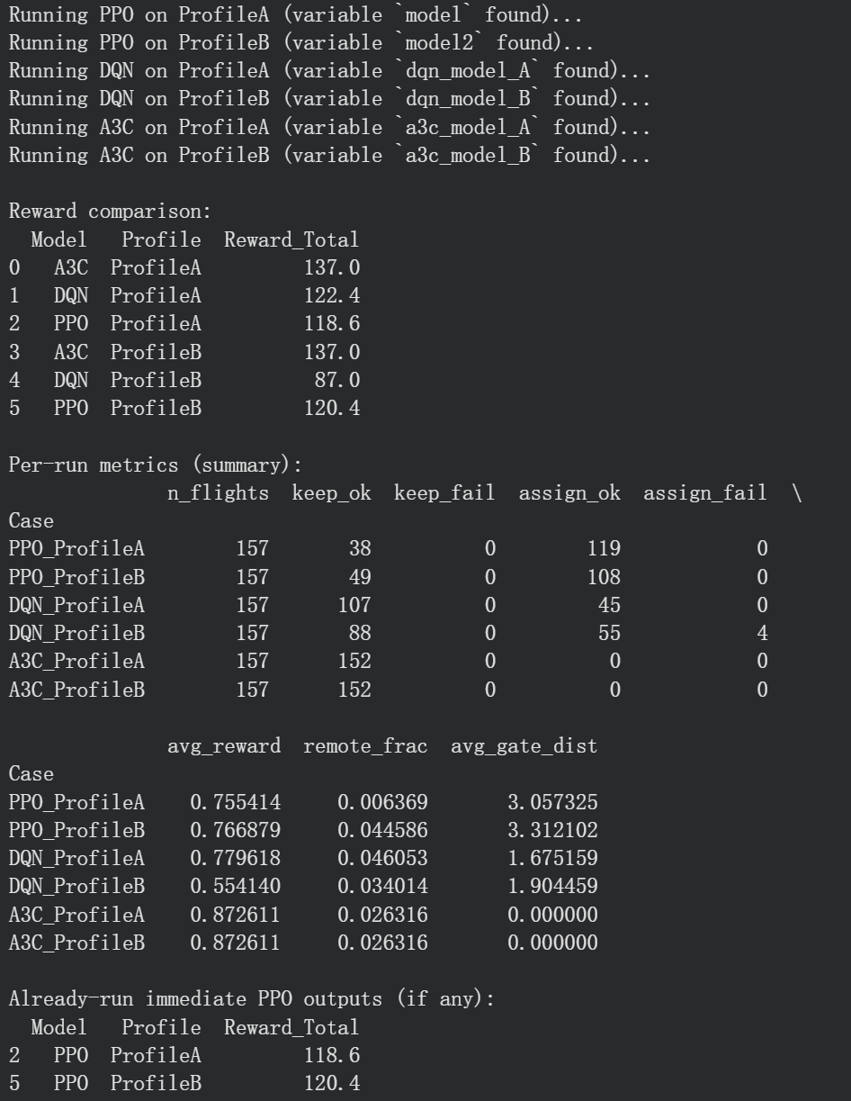
R_KEEP_OK = 0.9
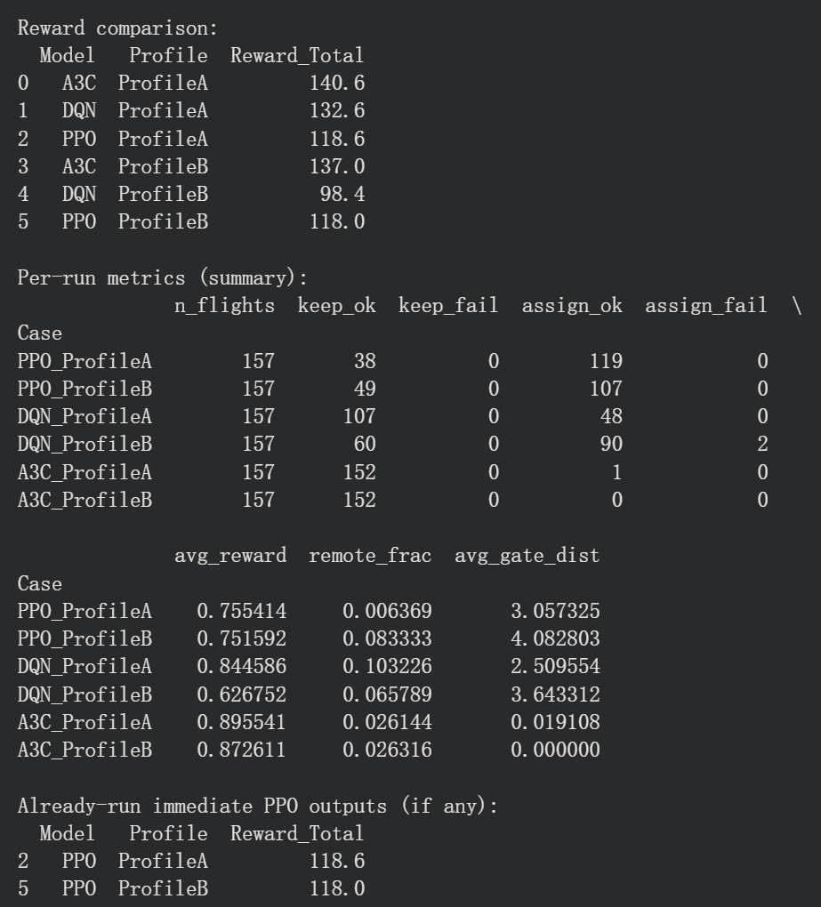
Problem why A3C keep all:
Flight arrives late. But departure time remains unchanged. Turn-around is compressed, but does not automatically cause overlap.
- Change wrong logic(correct turn around time constraint)
- First run
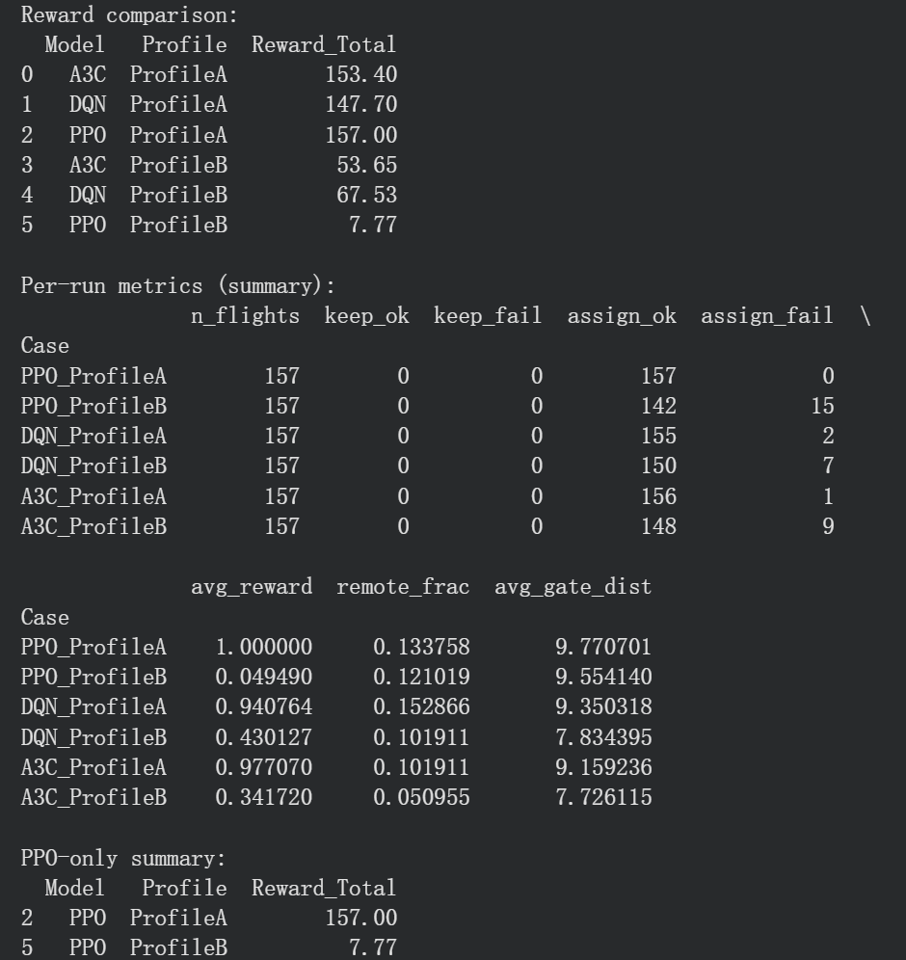
- Second run
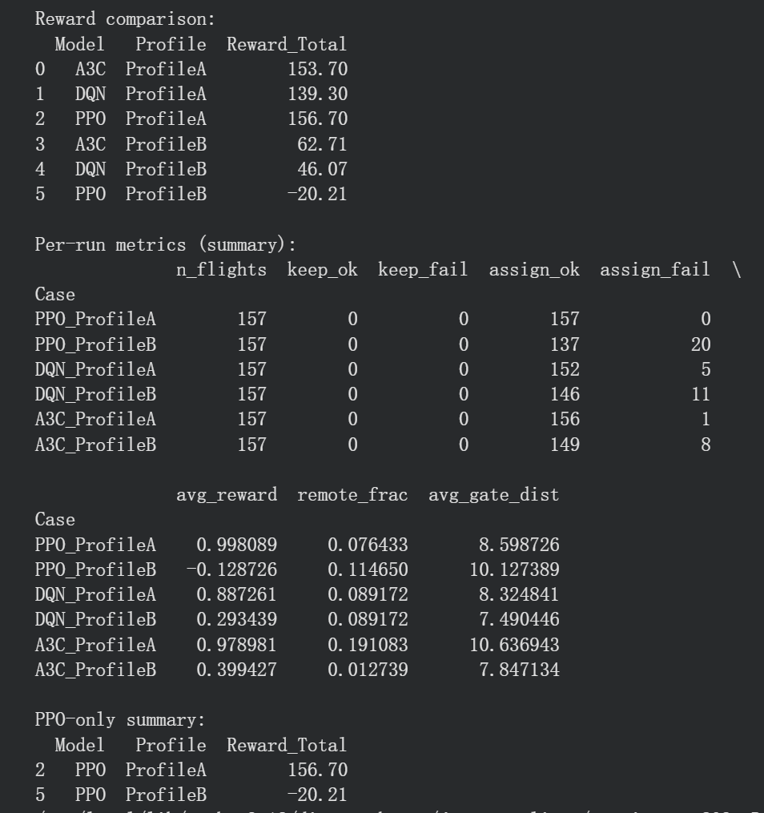
- Third run
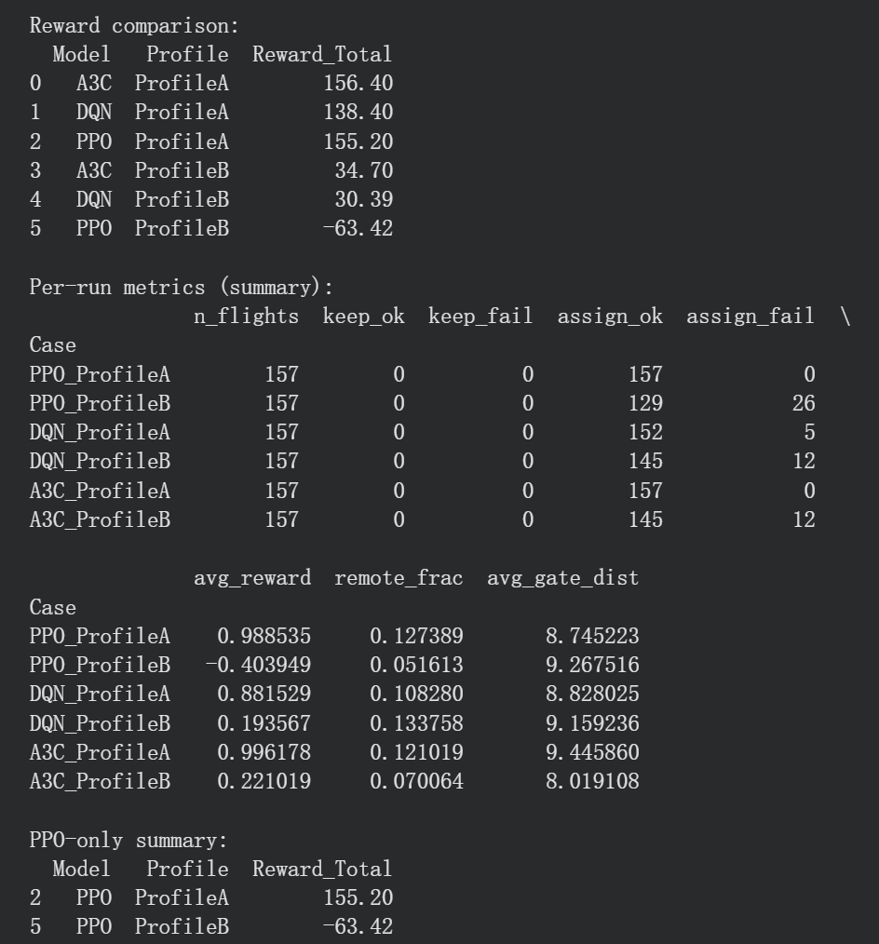
- Correct reward setting(make A & B consistent)
- First run
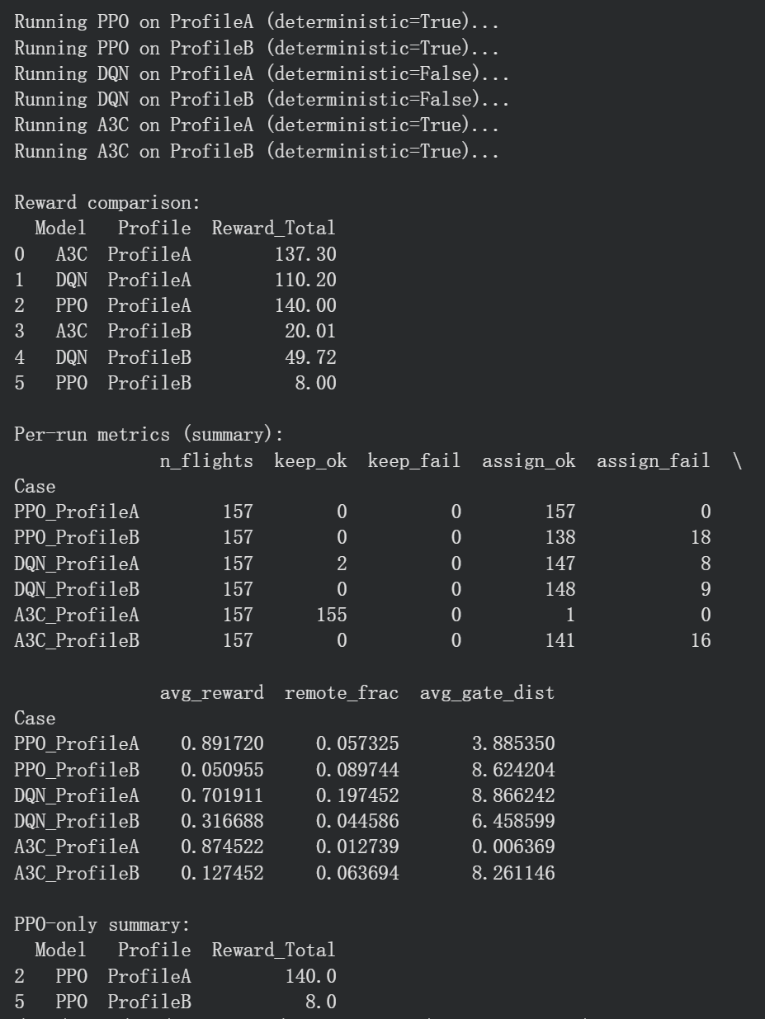
- Second run
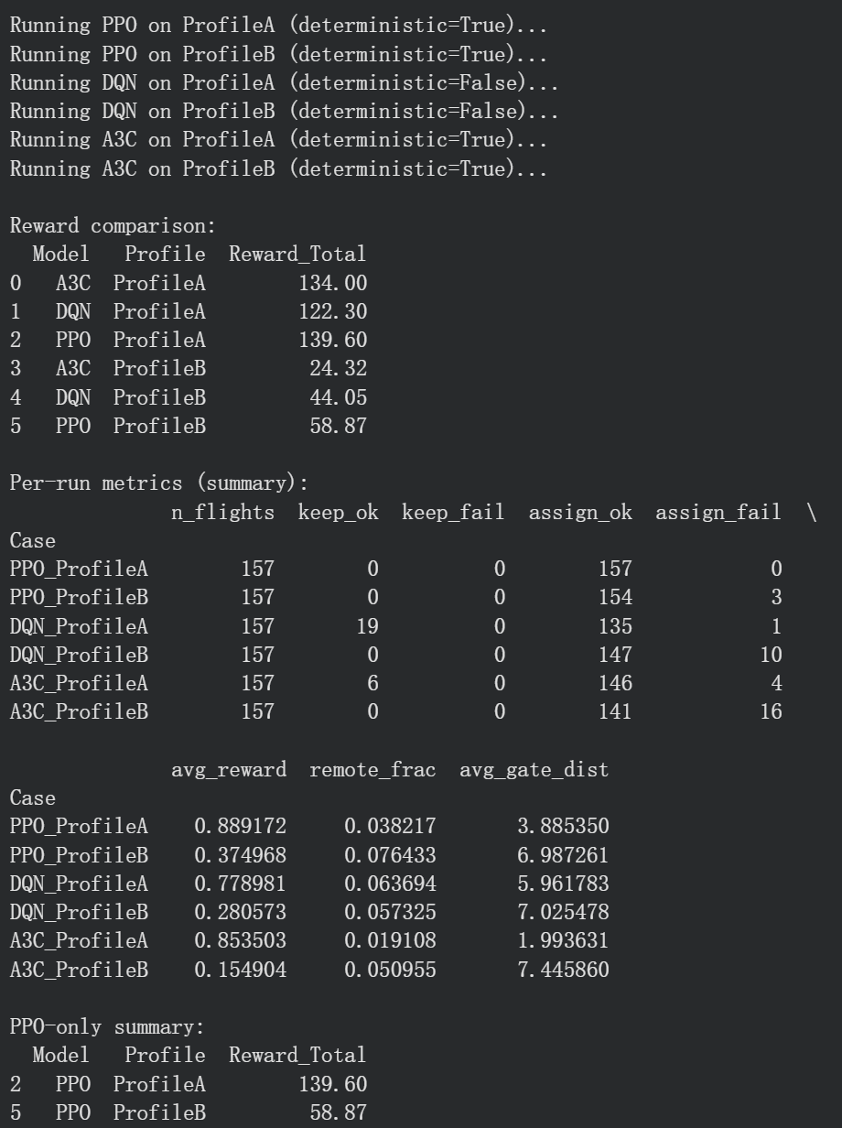
- Third run
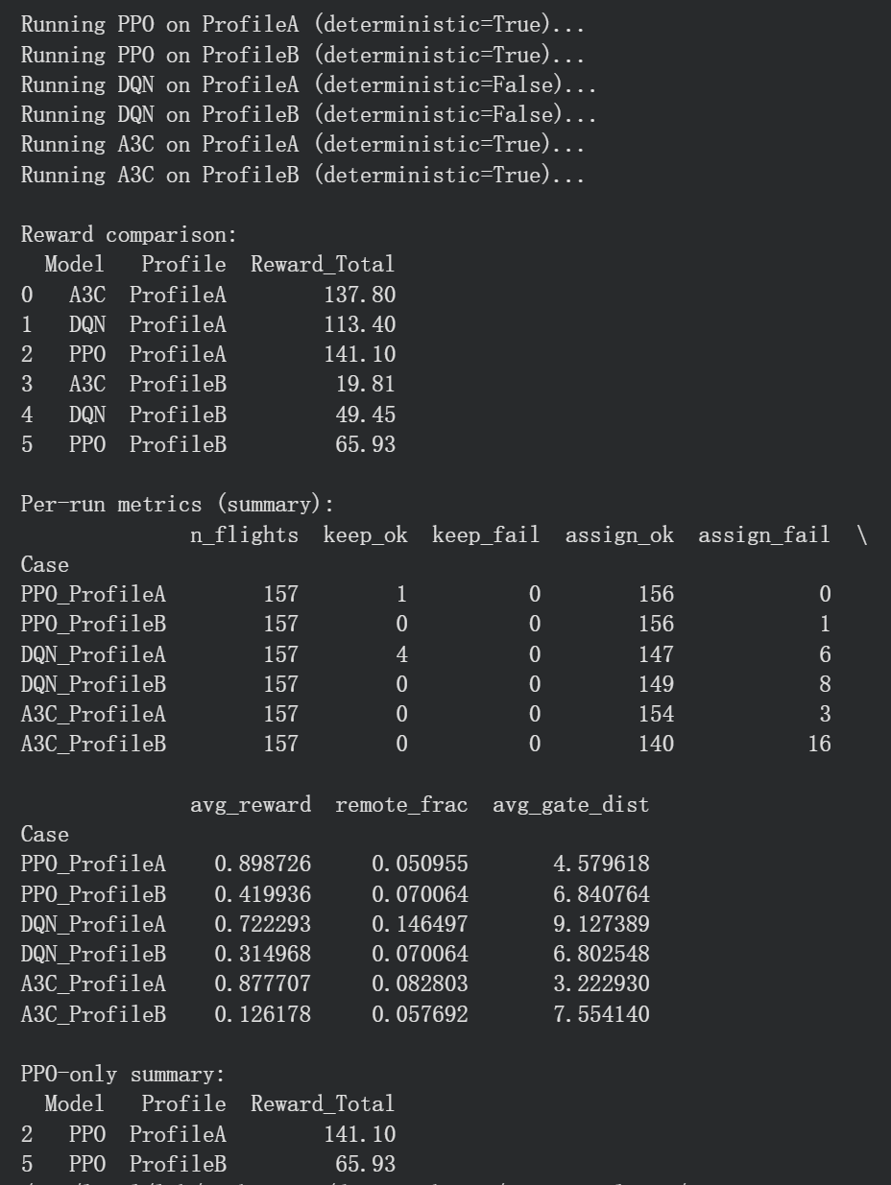
- Fourth run
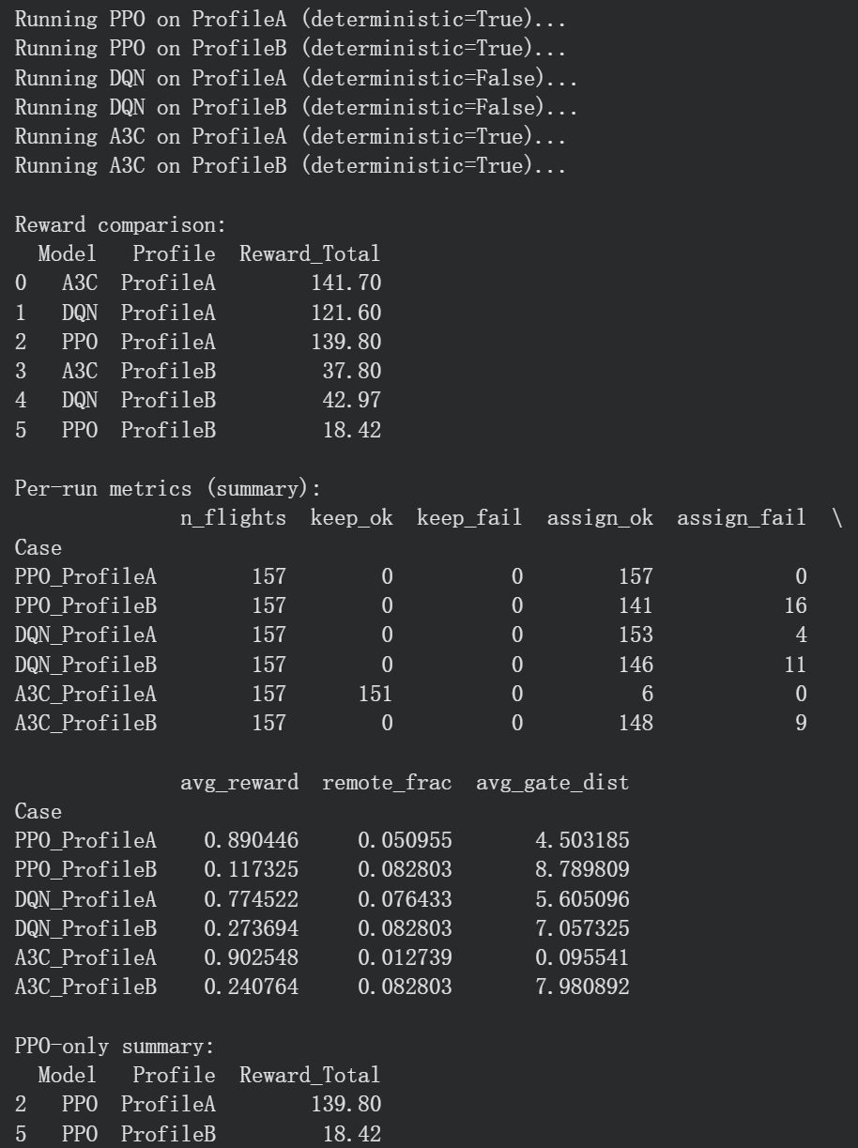
- Change deterministic setting and run 10 times to get average rewards
- First run
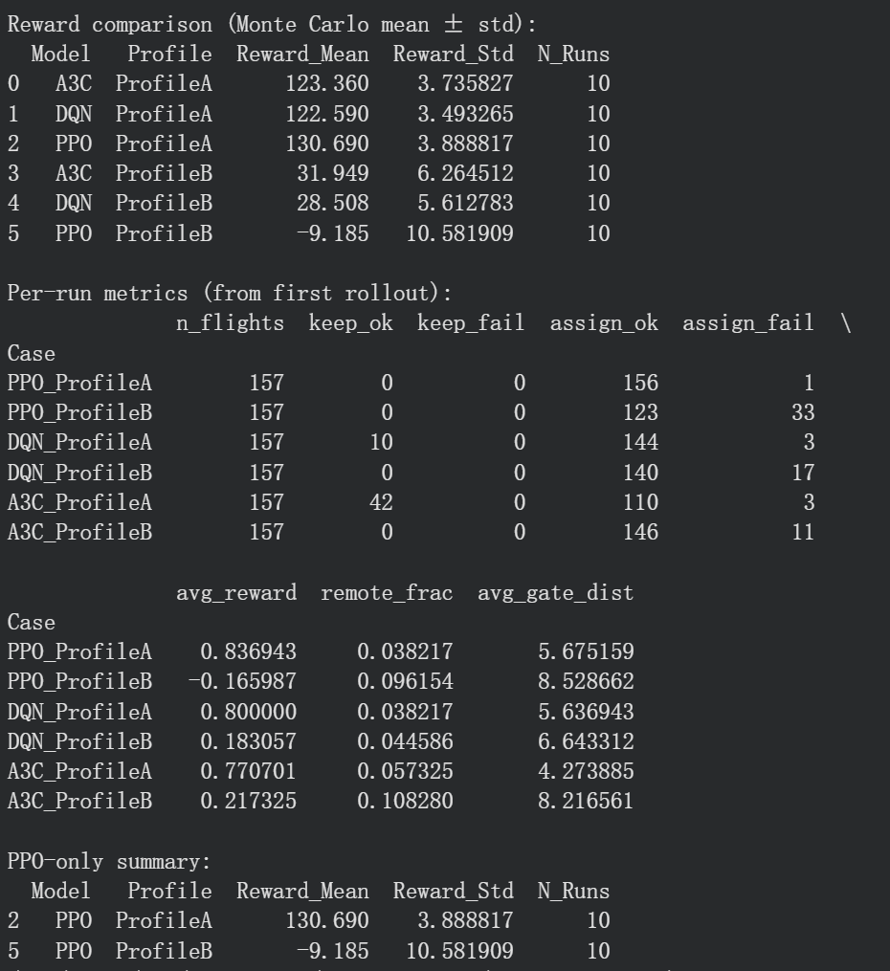
- Second run
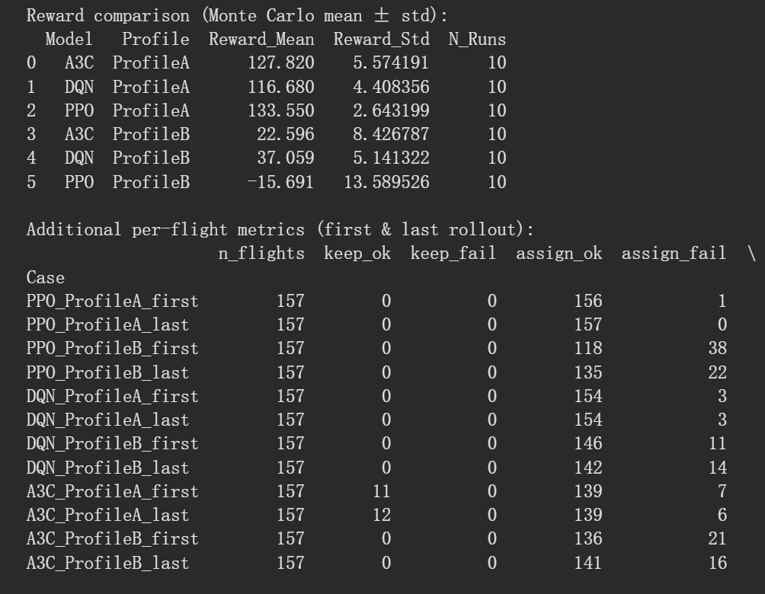
- Third run
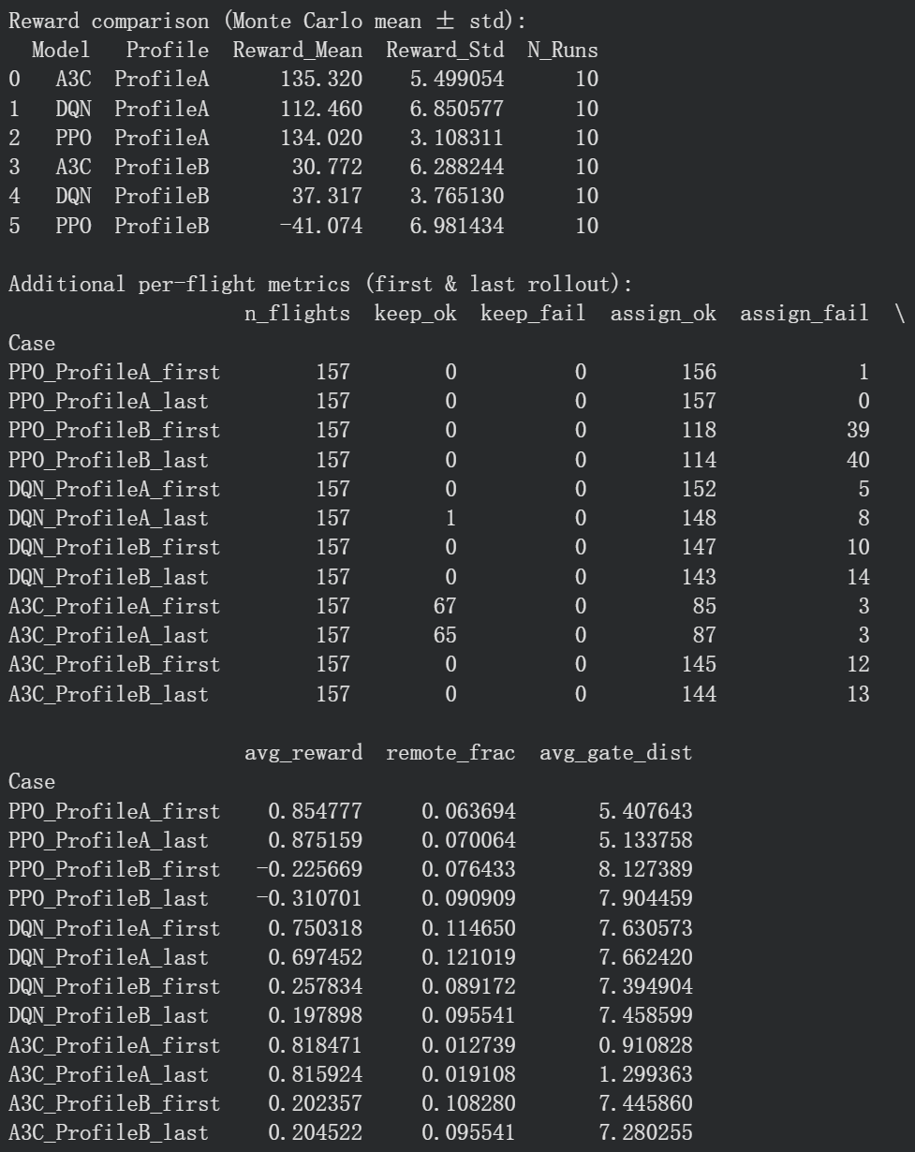
- Correct pre-allocation and reallocation
V4: preallocation is wrong
Copy: failed preallocation
Copy of copy: original chunk1

R_FAIL_ILLEGAL = -2.0
R_FAIL_KEEP_ILLEGAL = -3.0
- First run

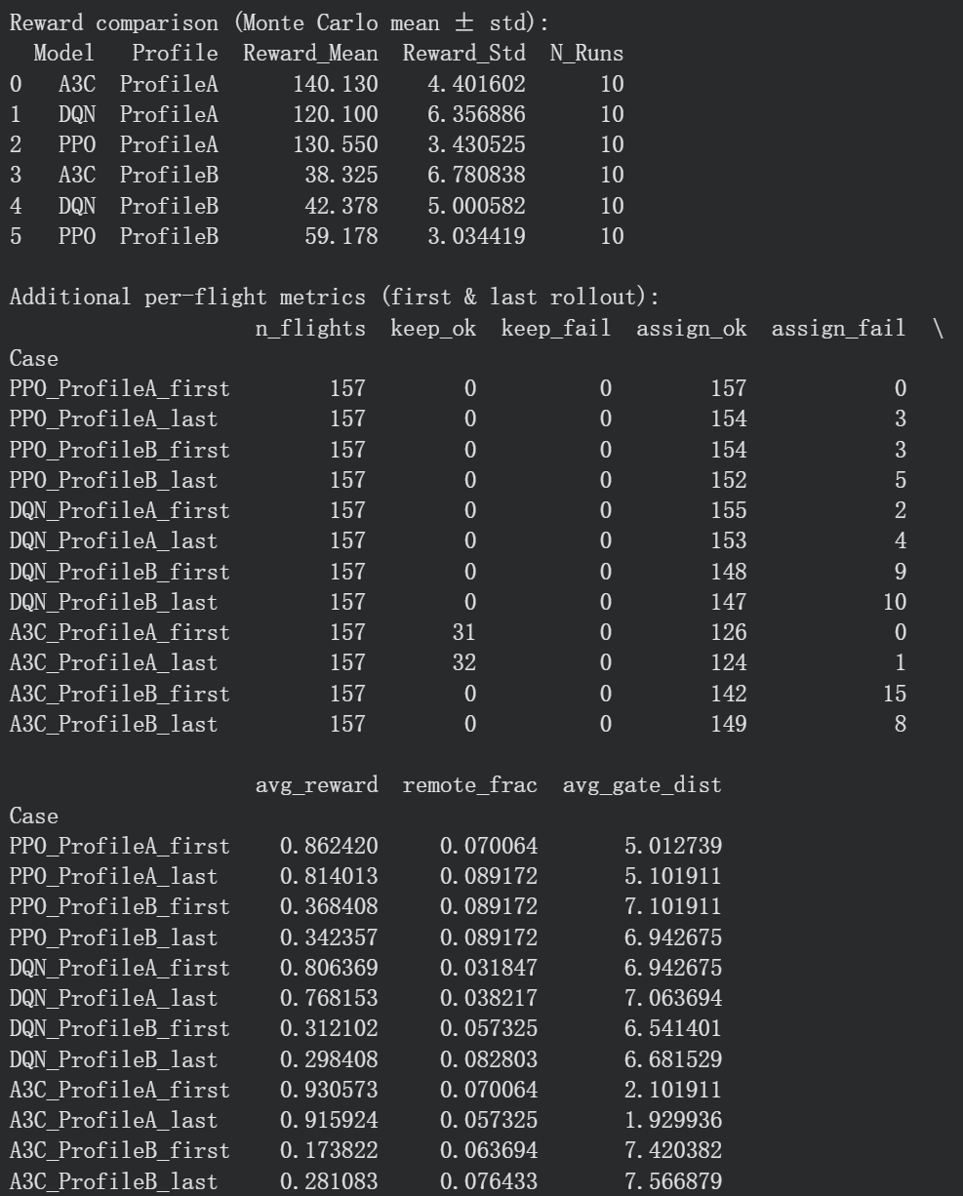
- Second run
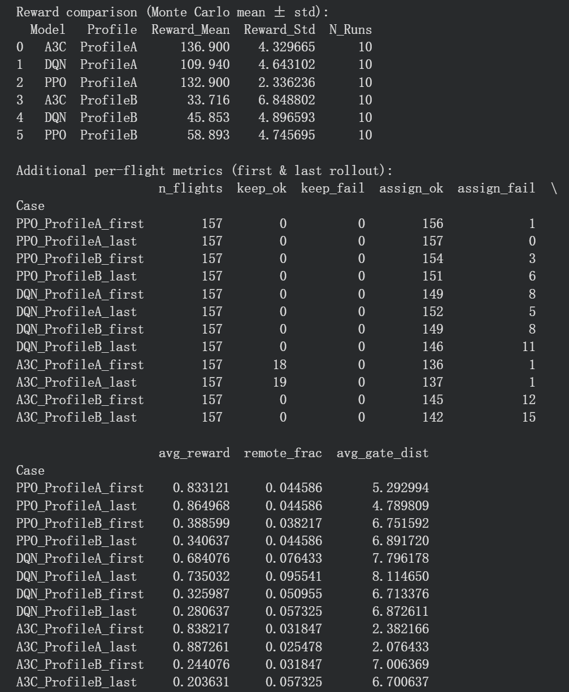
- Add fail assignment reward
- First run
R_FAIL_ILLEGAL = -4.0
R_FAIL_KEEP_ILLEGAL = -5.0
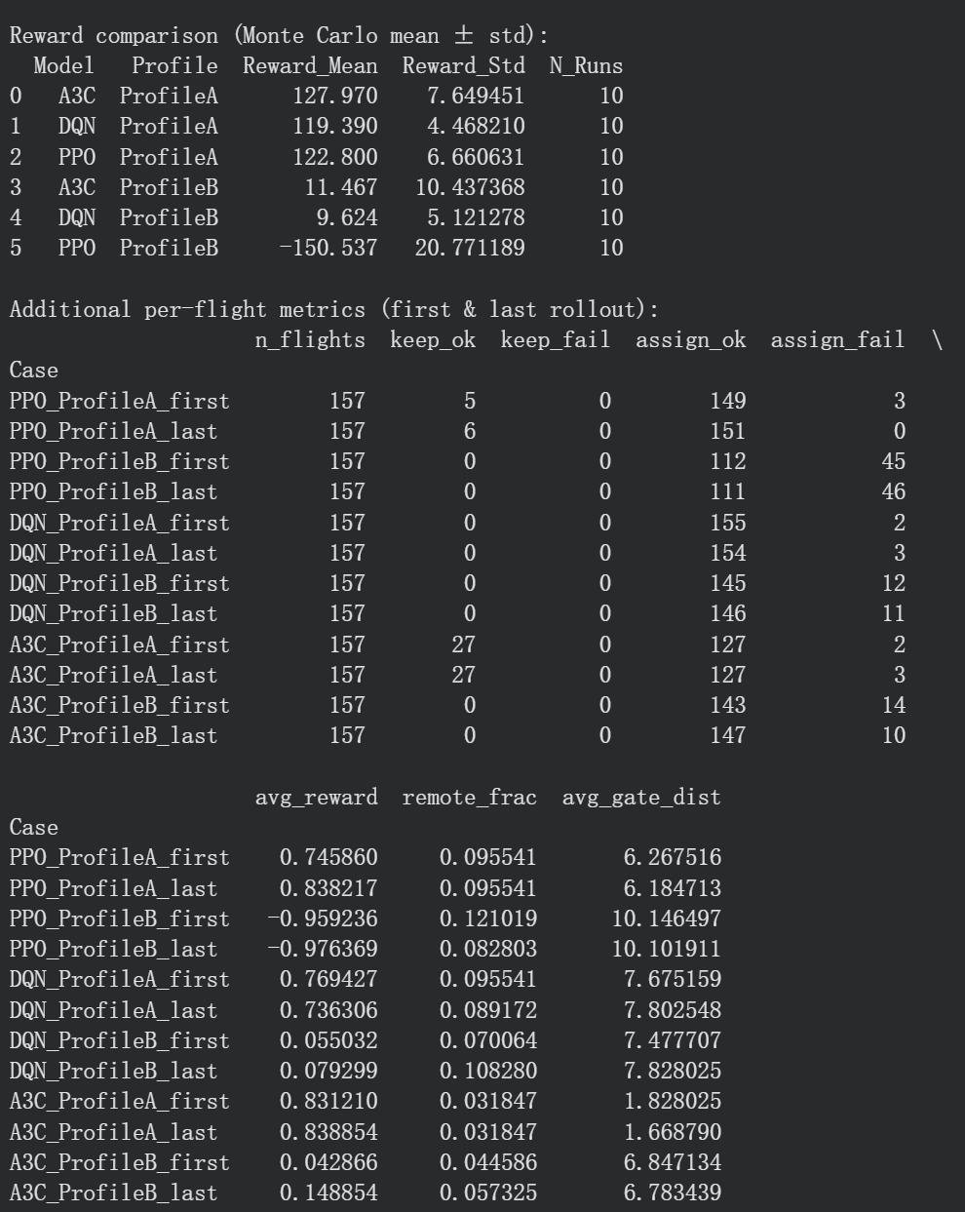
- Second run
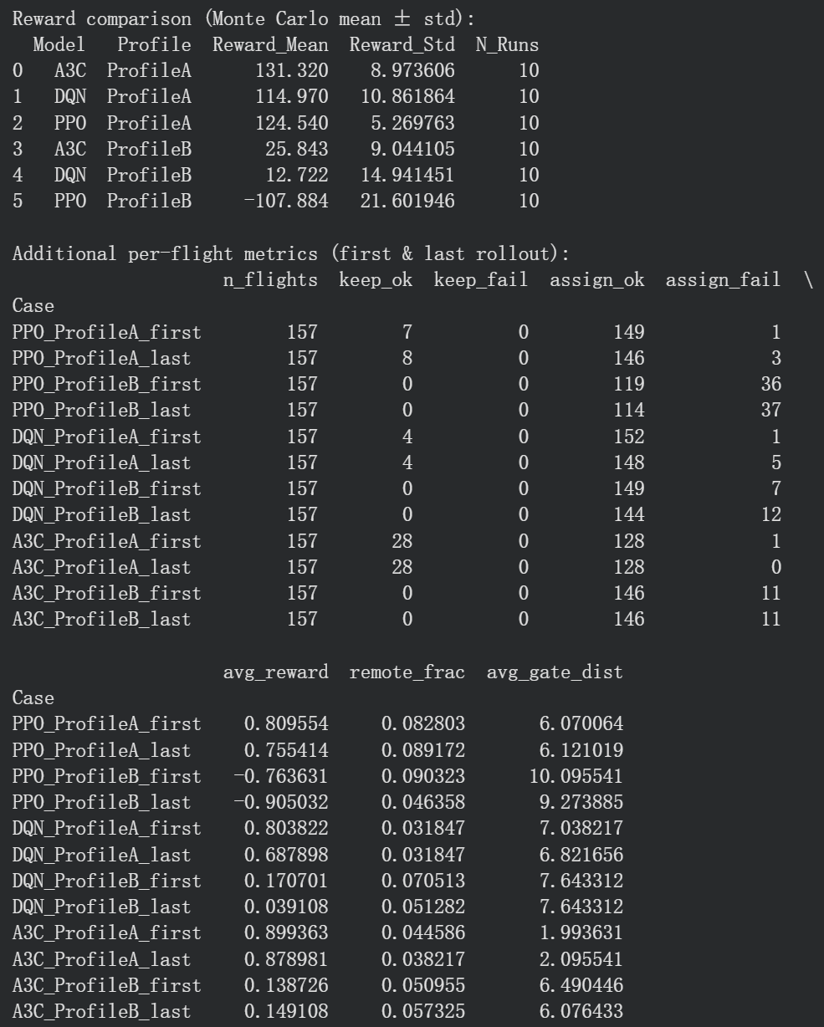
R_FAIL_ILLEGAL = -3.0
R_FAIL_KEEP_ILLEGAL = -4.0
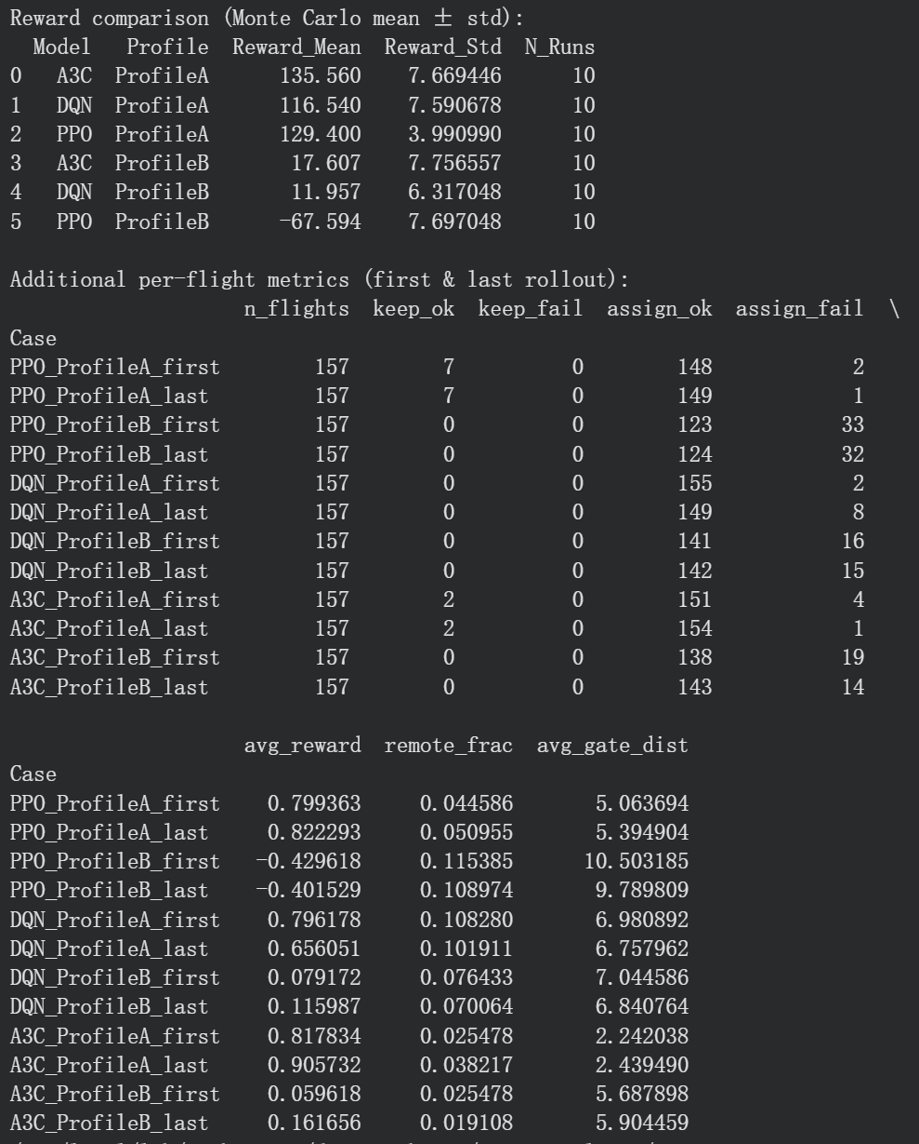
- Add run time
R_FAIL_ILLEGAL = -2.0
R_FAIL_KEEP_ILLEGAL = -3.0
- First run (run 10 times)
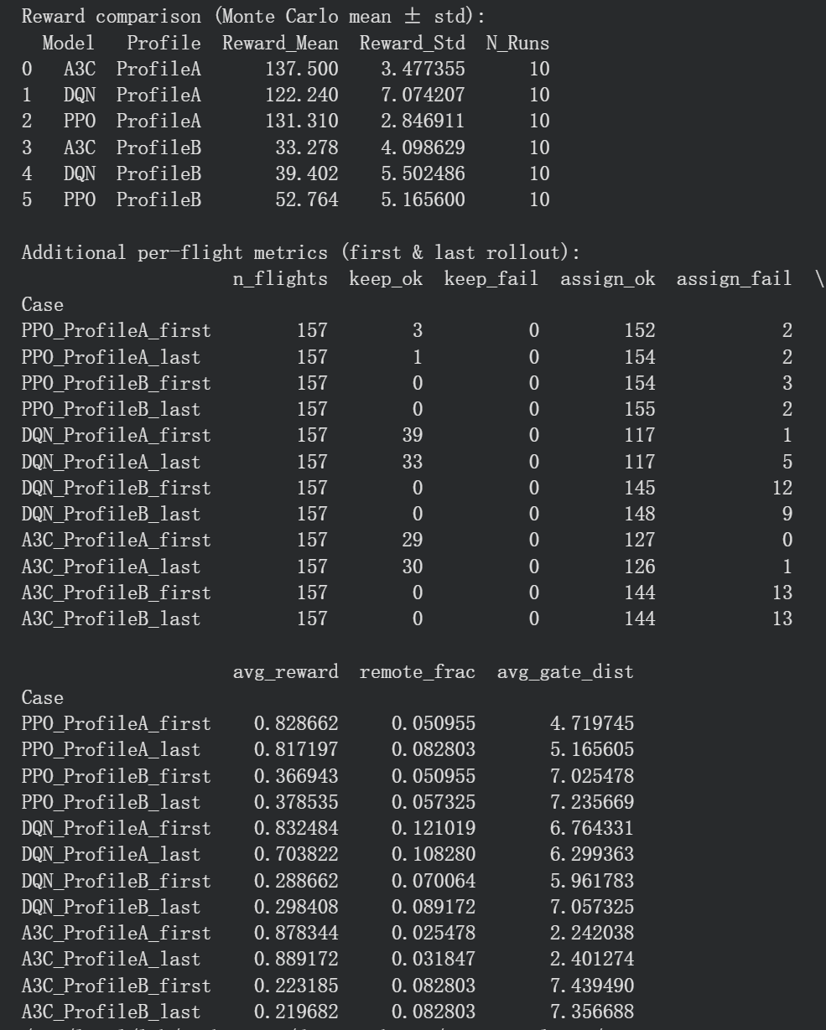
- second run (run 20 times)
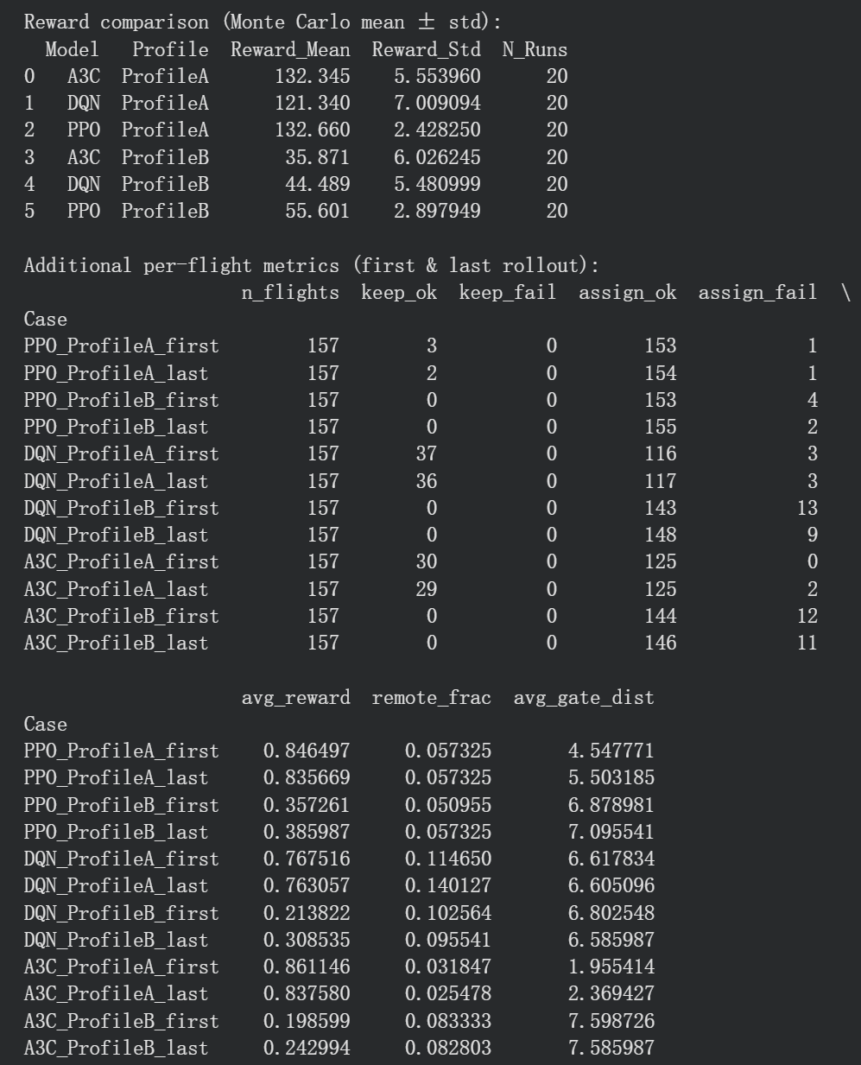
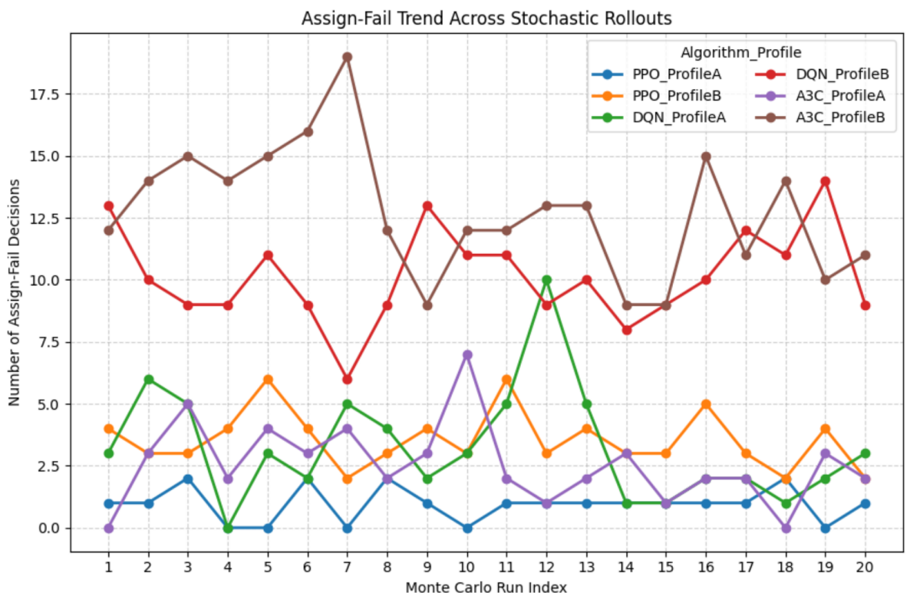

- Reduce delay flights
Run 10 times
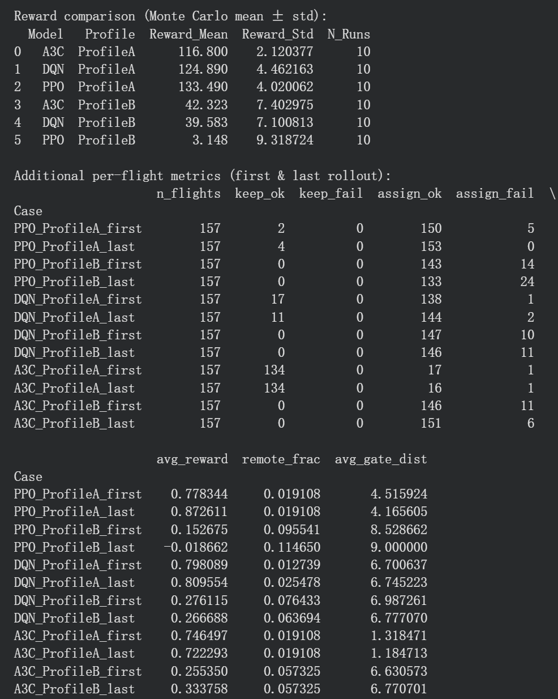

- Delete profile A
Reward comparison (Monte Carlo mean ± std):
Model Profile Reward_Mean Reward_Std N_Runs
0 A3C ProfileB 45.820 5.610889 10
1 DQN ProfileB 27.715 6.039734 10
2 PPO ProfileB -16.926 6.967005 10

Additional per-flight metrics (first & last rollout):
n_flights keep_ok keep_fail assign_ok assign_fail \
Case
PPO_ProfileB_first 157 0 0 127 29
PPO_ProfileB_last 157 0 0 124 32
DQN_ProfileB_first 157 0 0 143 14
DQN_ProfileB_last 157 0 0 142 15
A3C_ProfileB_first 157 0 0 149 8
A3C_ProfileB_last 157 0 0 142 15

avg_reward remote_frac avg_gate_dist
Case
PPO_ProfileB_first -0.083694 0.064103 7.968153
PPO_ProfileB_last -0.132548 0.076923 7.898089
DQN_ProfileB_first 0.196815 0.063694 7.624204
DQN_ProfileB_last 0.195414 0.057325 7.312102
A3C_ProfileB_first 0.338089 0.006369 6.140127
A3C_ProfileB_last 0.226688 0.006369 6.197452

- Enable fallback (with fallback penalty)
Reward comparison (Monte Carlo mean ± std):
Model Profile Reward_Mean Reward_Std N_Runs
0 A3C ProfileB 56.728 5.299598 10
1 DQN ProfileB 53.730 5.321457 10
2 PPO ProfileB 73.729 2.628149 10

Additional per-flight metrics (first & last rollout):
n_flights keep_ok keep_fail assign_ok assign_fail \
Case
PPO_ProfileB_first 157 0 0 141 0
PPO_ProfileB_last 157 0 0 149 0
DQN_ProfileB_first 157 0 0 136 2
DQN_ProfileB_last 157 0 1 131 2
A3C_ProfileB_first 157 0 1 121 1
A3C_ProfileB_last 157 0 0 122 1

avg_reward remote_frac avg_gate_dist
Case
PPO_ProfileB_first 0.453885 0.019108 5.471338
PPO_ProfileB_last 0.504076 0.012739 4.961783
DQN_ProfileB_first 0.371783 0.038710 5.254777
DQN_ProfileB_last 0.352803 0.032468 5.490446
A3C_ProfileB_first 0.316242 0.025806 5.617834
A3C_ProfileB_last 0.361465 0.025641 5.350318

- Delete fallback penalty
Reward comparison (Monte Carlo mean ± std):
Model Profile Reward_Mean Reward_Std N_Runs
0 A3C ProfileB 81.846 0.978879 10
1 DQN ProfileB 67.842 2.587635 10
2 PPO ProfileB 87.207 0.553643 10

Additional per-flight metrics (first & last rollout):
n_flights keep_ok keep_fail assign_ok assign_fail \
Case
PPO_ProfileB_first 157 0 0 38 0
PPO_ProfileB_last 157 0 0 31 0
DQN_ProfileB_first 157 0 0 29 0
DQN_ProfileB_last 157 0 0 29 0
A3C_ProfileB_first 157 0 0 25 0
A3C_ProfileB_last 157 0 0 19 0

avg_reward remote_frac avg_gate_dist
Case
PPO_ProfileB_first 0.550892 0.000000 2.732484
PPO_ProfileB_last 0.553503 0.000000 2.560510
DQN_ProfileB_first 0.455605 0.025478 4.044586
DQN_ProfileB_last 0.438280 0.019108 4.617834
A3C_ProfileB_first 0.524841 0.000000 2.668790
A3C_ProfileB_last 0.522420 0.006369 2.713376

- Delete BONUS_PEAK_SUCCESS
Reward comparison (Monte Carlo mean ± std):
Model Profile Reward_Mean Reward_Std N_Runs
0 A3C ProfileB 53.818 4.220481 10
1 DQN ProfileB 54.141 3.617404 10
2 PPO ProfileB 72.565 3.767891 10

Additional per-flight metrics (first & last rollout):
n_flights keep_ok keep_fail assign_ok assign_fail \
Case
PPO_ProfileB_first 157 0 0 146 0
PPO_ProfileB_last 157 0 0 149 0
DQN_ProfileB_first 157 0 0 128 1
DQN_ProfileB_last 157 0 0 128 0
A3C_ProfileB_first 157 0 0 130 1
A3C_ProfileB_last 157 0 0 129 1

- Add airline_pref_ok_rate
Reward comparison (Monte Carlo mean ± std):
Model Profile Reward_Mean Reward_Std N_Runs
0 A3C ProfileB 56.614 5.026345 10
1 DQN ProfileB 59.522 4.057676 10
2 PPO ProfileB 72.889 2.749405 10

Additional per-flight metrics (first & last rollout):
n_flights keep_ok keep_fail assign_ok assign_fail \
Case
PPO_ProfileB_first 157 0 0 142 0
PPO_ProfileB_last 157 0 0 147 0
DQN_ProfileB_first 157 0 0 126 1
DQN_ProfileB_last 157 0 0 137 0
A3C_ProfileB_first 157 0 0 126 0
A3C_ProfileB_last 157 0 0 135 1

avg_reward remote_frac avg_gate_dist \
Case
PPO_ProfileB_first 0.446242 0.038217 4.929936
PPO_ProfileB_last 0.486752 0.031847 4.694268
DQN_ProfileB_first 0.383312 0.032051 5.598726
DQN_ProfileB_last 0.427707 0.031847 5.184713
A3C_ProfileB_first 0.364204 0.038217 4.987261
A3C_ProfileB_last 0.362803 0.032051 5.146497

airline_pref_ok_rate
Case
PPO_ProfileB_first 0.668790
PPO_ProfileB_last 0.719745
DQN_ProfileB_first 0.608974
DQN_ProfileB_last 0.656051
A3C_ProfileB_first 0.649682
A3C_ProfileB_last 0.666667

- Compare with Greedy Heuristic
n_flights keep_ok keep_fail assign_ok assign_fail avg_reward \
0 157 120 0 37 0 0.805732
remote_frac avg_gate_dist airline_pref_ok_rate
0 0.006369 0.828025 0.917197

- Change keep reward
R_KEEP_OK = 0.9
R_ASSIGN_SAME_OK = 1.0
To
R_KEEP_OK = 1.0
R_ASSIGN_SAME_OK = 1.0

Reward comparison (Monte Carlo mean ± std):
Model Profile Reward_Mean Reward_Std N_Runs
0 A3C ProfileB 53.687 5.717905 10
1 DQN ProfileB 53.719 4.131304 10
2 PPO ProfileB 69.640 4.334764 10

Additional per-flight metrics (first & last rollout):
n_flights keep_ok keep_fail assign_ok assign_fail \
Case
PPO_ProfileB_first 157 0 0 140 0
PPO_ProfileB_last 157 0 0 142 0
DQN_ProfileB_first 157 0 0 127 0
DQN_ProfileB_last 157 0 0 126 0
A3C_ProfileB_first 157 0 0 120 2
A3C_ProfileB_last 157 0 0 125 2

avg_reward remote_frac avg_gate_dist \
Case
PPO_ProfileB_first 0.424650 0.019108 4.694268
PPO_ProfileB_last 0.480573 0.019108 4.643312
DQN_ProfileB_first 0.376561 0.044586 5.369427
DQN_ProfileB_last 0.367452 0.038217 5.280255
A3C_ProfileB_first 0.330764 0.032258 4.605096
A3C_ProfileB_last 0.311975 0.019355 4.853503

airline_pref_ok_rate
Case
PPO_ProfileB_first 0.668790
PPO_ProfileB_last 0.687898
DQN_ProfileB_first 0.611465
DQN_ProfileB_last 0.668790
A3C_ProfileB_first 0.670968
A3C_ProfileB_last 0.593548

Greedy Heuristic (Rule-based):
n_flights keep_ok keep_fail assign_ok assign_fail avg_reward \
0 157 120 0 37 0 0.882166

remote_frac avg_gate_dist airline_pref_ok_rate
0 0.006369 0.828025 0.917197

- Change the logic of keep
Reward comparison (Monte Carlo mean ± std):
Model Profile Reward_Mean Reward_Std N_Runs
0 A3C ProfileB 31.635 1.289963 10
1 DQN ProfileB 44.320 2.750262 10
2 PPO ProfileB 62.840 3.846037 10

Additional per-flight metrics (first & last rollout):
n_flights auto_keep reassign_ok reassign_fail \
Case
PPO_ProfileB_first 157 85 0 0
PPO_ProfileB_last 157 86 0 0
DQN_ProfileB_first 157 109 0 0
DQN_ProfileB_last 157 107 0 0
A3C_ProfileB_first 157 120 0 0
A3C_ProfileB_last 157 121 0 0

avg_reward remote_frac avg_gate_dist \
Case
PPO_ProfileB_first 0.422548 0.006369 2.273885
PPO_ProfileB_last 0.417707 0.006369 2.318471
DQN_ProfileB_first 0.278025 0.006369 1.560510
DQN_ProfileB_last 0.293949 0.006369 1.528662
A3C_ProfileB_first 0.204650 0.006369 1.522293
A3C_ProfileB_last 0.201783 0.006369 1.331210

airline_pref_ok_rate
Case
PPO_ProfileB_first 0.828025
PPO_ProfileB_last 0.834395
DQN_ProfileB_first 0.802548
DQN_ProfileB_last 0.815287
A3C_ProfileB_first 0.885350
A3C_ProfileB_last 0.878981

Greedy:
n_flights auto_keep reassign_ok reassign_fail reward avg_reward \
0 157 120 37 0 38.25 0.243631

remote_frac avg_gate_dist airline_pref_ok_rate
0 0.006369 0.828025 0.917197

